**Station 1: Play CIA**

**Instructions**

* **Learn about the Caesar and Vigenere ciphers and how they are used to encode texts in the question sheet.**
* 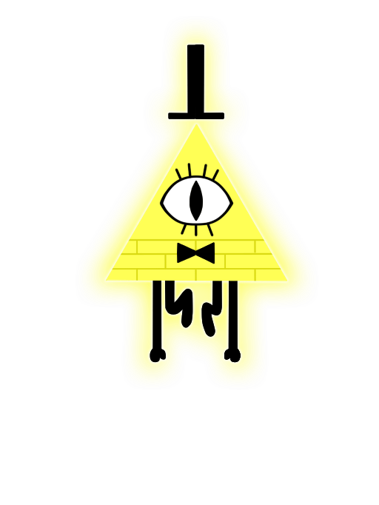**Use the Caesar and Vigenere ciphers to decode and solve the various questions given to you to earn some points.**
* **Ignore all capitalization, punctuation, and spaces.**
* **You may ask for two hints per question, although this will dock 10 points off your total score per hint.**
* **Feel free to ask the station masters if you seek any clarifications.**

**Resources**

**The English Alphabet (in case your forgot):**

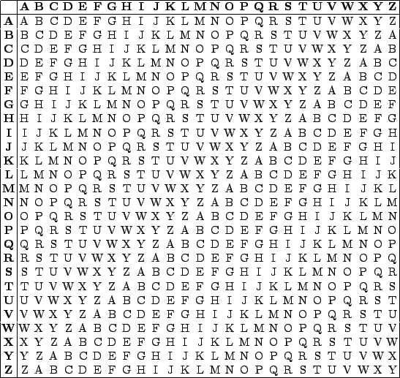**A B C D E F G H I J K L M N O P Q R S T U V W X Y Z**

**Vigenere Square 🡪**

**(and how to use)**

Encoded text: DQINZILCBNKCU

+ Key: YEAYEAYEAYEAY

…

Result: BUILDINGBLOCS

Ibwf gvo efdpejoh !